# SPRINT 2: Classification of Arrhythmia by Using Deep Learning With 2-D ECG Spectral Image Representation

**Team ID: PNT2022TMID24237**

**Team Members: S.Krishnasai,S.Saikiran,V.Madhuri,Vignesh.K**

**Code**: Updated in GitHub in the Deliverables section in Sprint1 folder.

# Description of USN and Screenshots:

**USN-4:**

As a user, I want quality data to be collected for the purposes of training the model. Also, image processing methods must be employed to pre-process the dataset.

# Screenshot:

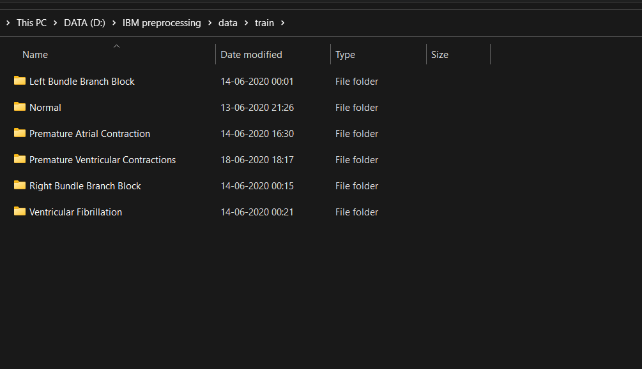

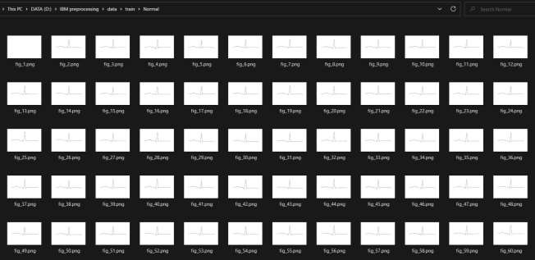

**Image Split:**

**Left Bundle Branch Block –** 504 images

**Normal –** 7436 images

**Premature Atrial Contraction –** 2054 images **Premature Ventricular Contractions –** 2759 images **Right Bundle Branch Block –** 2239 images **Ventricular Fibrillation –** 439 images

For reducing skewness in the dataset, ImageDataGenerator class was used for both processing and handling with data imbalance.

# USN-3:

As a user, I want the ML model to be as accurate as possible.

# Screenshot:

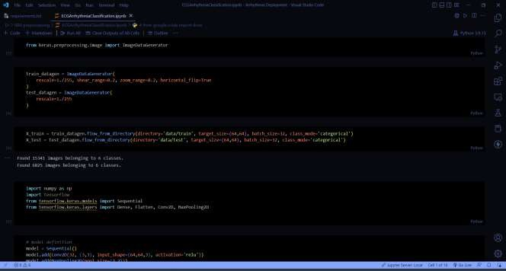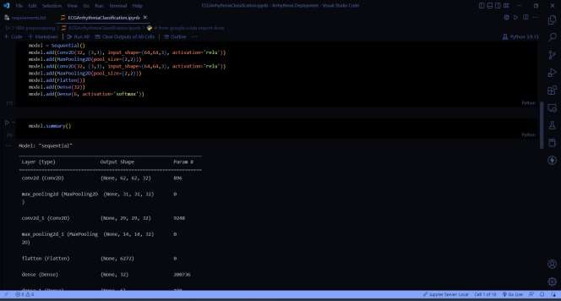

**Model Architecture:**

Model: "sequential"

Layer (type) Output Shape Param #

=================================================================

conv2d (Conv2D) (None, 62, 62, 32) 896

max_pooling2d (MaxPooling2D (None, 31, 31, 32)) 0

conv2d_1 (Conv2D) (None, 29, 29, 32) 9248

max_pooling2d_1 (MaxPooling (None, 14, 14, 32) 2D) 0

|  |  |  |
| --- | --- | --- |
| flatten (Flatten) | (None, 6272) | 0 |
| dense (Dense) | (None, 32) | 200736 |
| dense_1 (Dense) | (None, 6) | 198 |

=================================================================

Total params: 211,078

Trainable params: 211,078

Non-trainable params: 0

